library IEEE;

use IEEE.STD_LOGIC_ARITH.ALL;

use IEEE.STD_LOGIC_UNSIGNED.ALL;

use IEEE.STD_LOGIC_1164.ALL;

entity fourbitcounter is

port( Number: in std_logic_vector(0 to 3);

rst: in std_logic;

dr: in std_logic;

clk: in std_logic;

Ld: in std_logic;

output: out std_logic_vector(0 to 3) );

end fourbitcounter;

architecture Behavioral of fourbitcounter is

signal temp: std_logic_vector(0 to 3);

begin

process(clk,rst)

begin

if rst='1' then

temp <= "0000";

elsif ( clk'event and clk='1') then

if Ld='1' then

temp <= Number;

elsif (Ld='0' and dr='0') then

temp <= temp + 1;

elsif (Ld='0' and dr='1') then

temp <= temp - 1;

end if;

end if;

end process;

output <= temp;

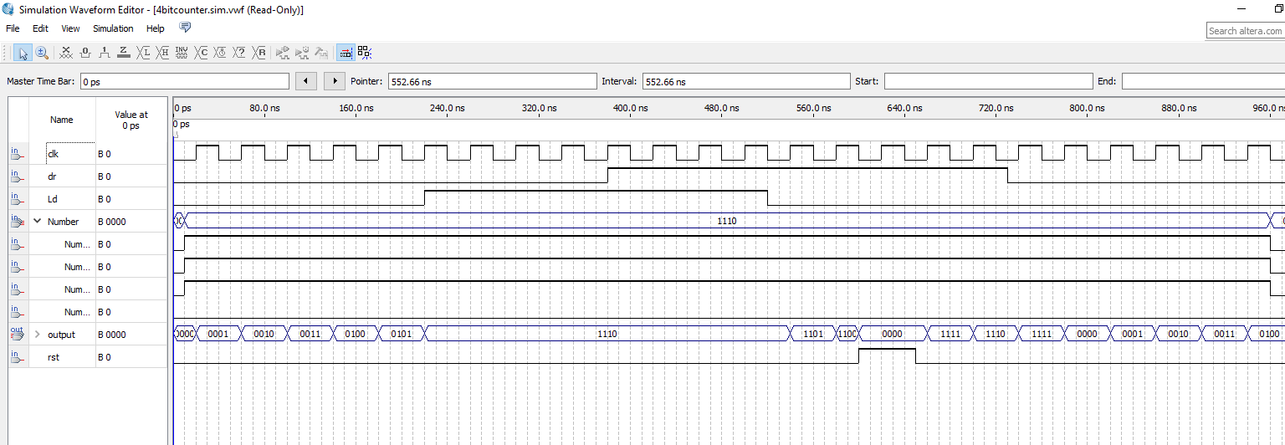end Behavioral;